**Structured Query Language (SQL)**

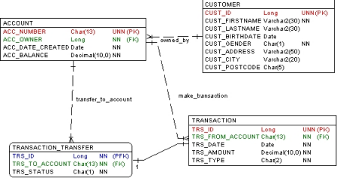

Note:

UNN : Unique, Not Null

PK : Primary Key

FK : Foreign Key

NN : Not Null

Table description:

1. CUSTOMER: contains all bank customer data

The column CUST_GENDER is set to 1 for male and 2 for female.

2. ACCOUNT: contains all customer accounts

The column ACC_OWNER is the Foreign Key which refers to the column CUST_ID of the table CUSTOMER.

3. TRANSACTION: records all transactions.

The column TRS_TYPE contains the transaction type with possible values: a. DB: for debit transaction.

b. CR: for credit transaction.

c. TF: for money transfer. The column TRS_FROM_ACCOUNT contains the source account.

4. TRANSACTION_TRANSFER: contains additional information if the transaction is money transfer.

The column TRS_STATUS contains one of the following values:

a. 0: if transaction is not executed yet

b. 1: if transaction is executed successfully

c. -1: if transaction is failed (e.g. the balance of source account

(TRS_FROM_ACCOUNT) is not available)

**Questions**

Create SQL queries for the following requirements:

1. Recapitulation of number of accounts owned by every customer. Answer:

SELECT * FROM customer

INNER JOIN account ON customer.CUST_ID = account.ACC_OWNER;

2. All transactions created by John Michael sorted by account number and transaction date

Answer:

SELECT customer.CUST_FRISTNAME, customer.CUST_LASTNAME, account.ACC_NUMBER,transaction.TRS_FROM_ACCOUNT,transaction.TRS_DATE

FROM customer

INNER JOIN account ON customer.CUST_ID = account.ACC_OWNER

INNER JOIN transaction ON account.ACC_NUMBER = transaction.TRS_FROM_ACCOUNT WHERE transaction.TRS_FROM_ACCOUNT = 'ACC3' ORDER BY transaction.TRS_DATE DESC;

SELECT * FROM transaction WHERE trs_from_account = 'ACC3'ORDER BY TRS_DATE DESC;